**Step Groups**

* Step group is a set of steps clubbed or grouped under one group.
* The step group can be created by selecting the multiple steps from script.
* The step groups can be called whenever it is required same like NLP’s in automation scripts.
* With the help of step groups, we can reduce the redundant steps access the different automation scripts.
* This will also help in faster development of test scripts.

**There are 4 types of step groups base on the input arguments and return value**

1.Step Group with no input argument and no return value.

2.Step group with no input argument and with return value.

3. Step group with input argument and with no return value.

4. Step group with input argument and with return value.

**How to create Step Group in FireFlink?**

* Before we create a step group we need to create container i.e., Library (This also should be in tree structure).
* To create a library, click on “Repo” and click on +Library button.

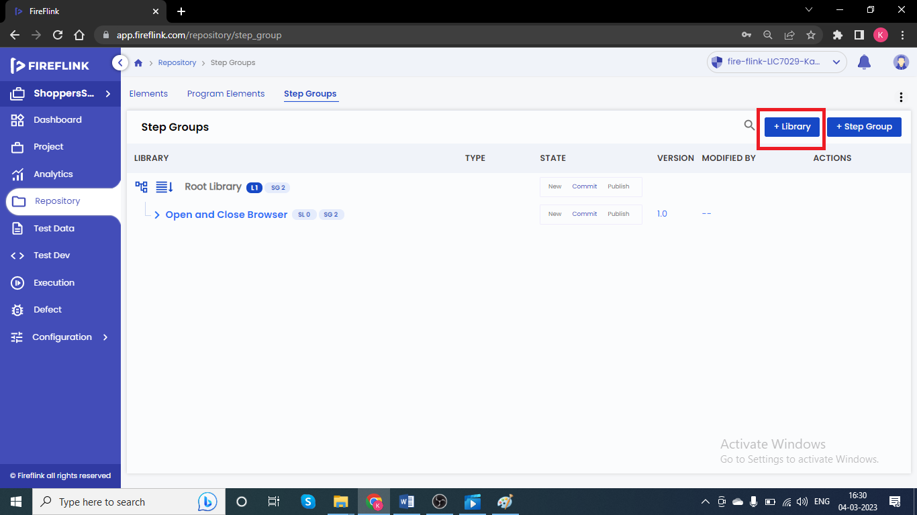

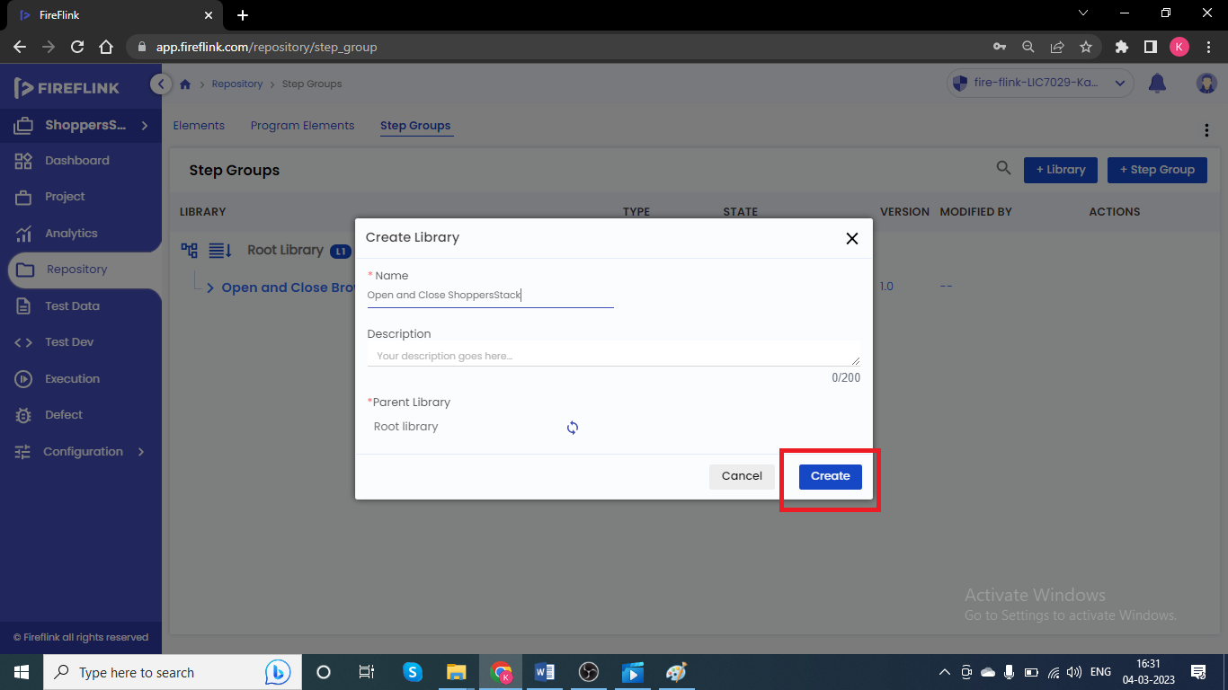

The step Groups can be created in two ways

1.The step Group can be created by selecting the steps from any of the existing automation script.

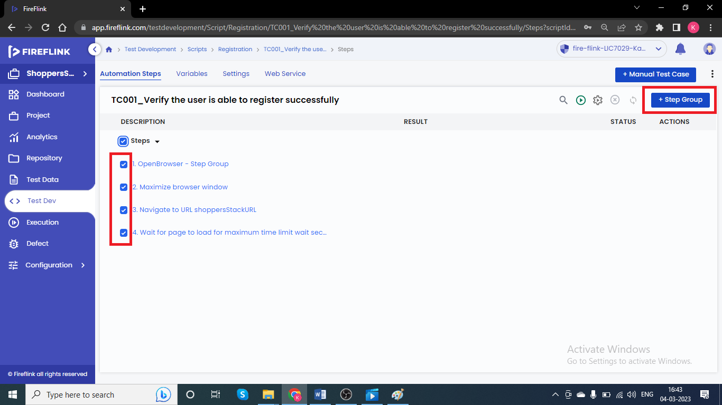

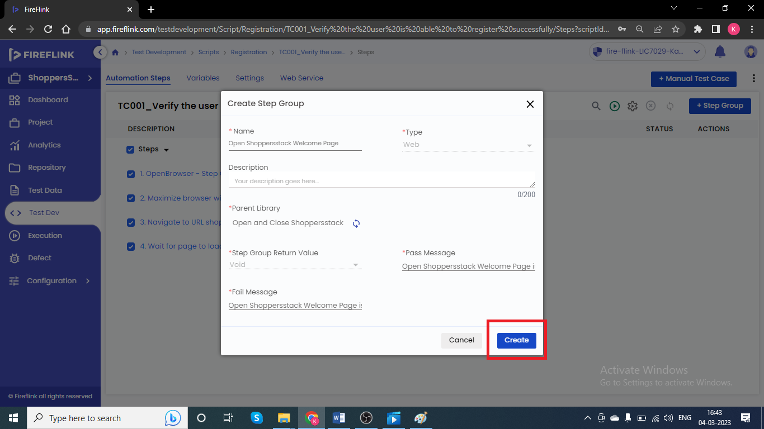

2.Go to repo---> Go to Step Group tab--> Click on +Step Group and provide the necessary details and click on create and add the steps inside it.

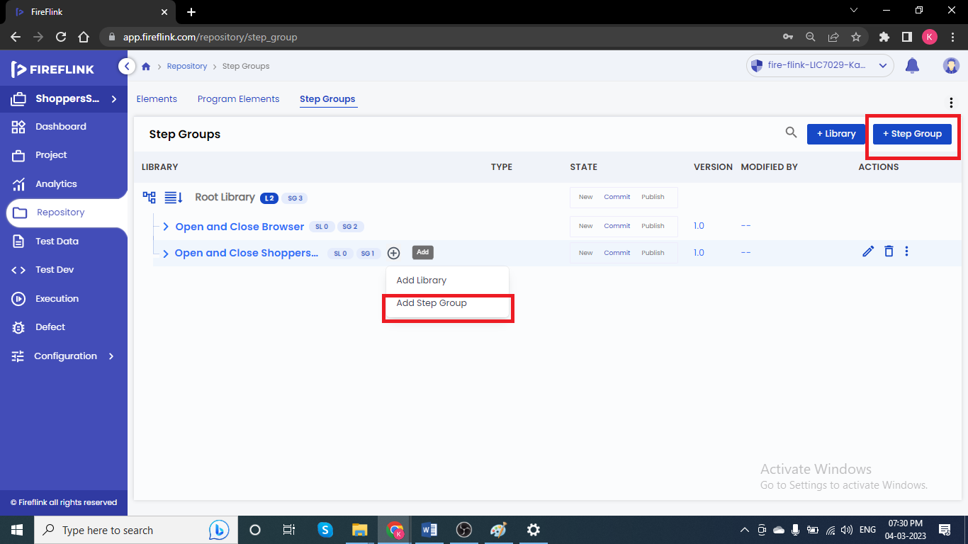

**How to create Step Group with Parameter?**

* Go to Repository --> Go to Step group tab ---> Create Step Group---> Click on Parameters and create the parameters here by selecting the datatypes.

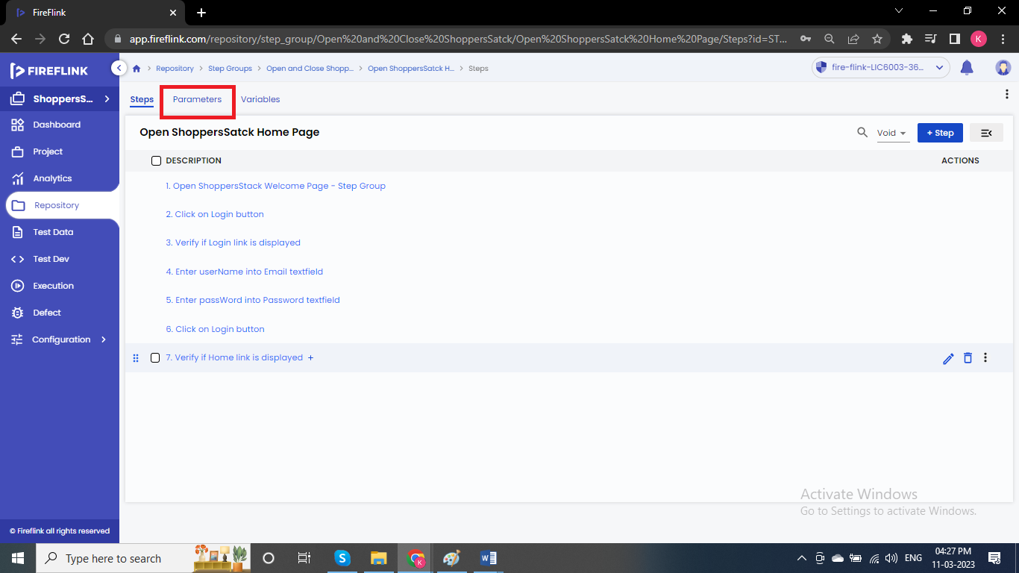

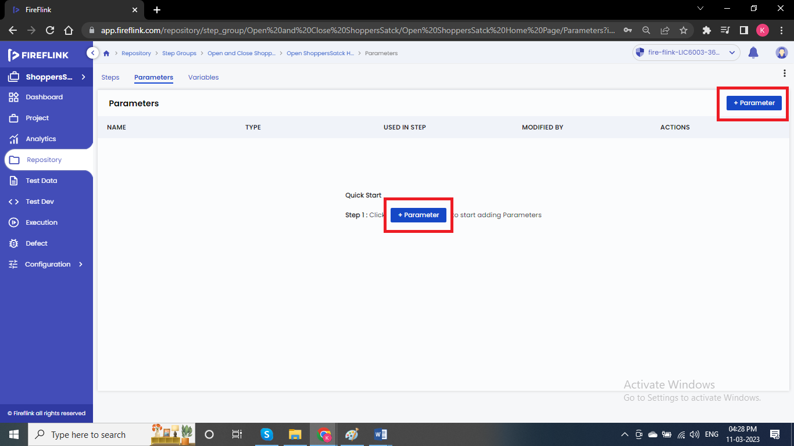

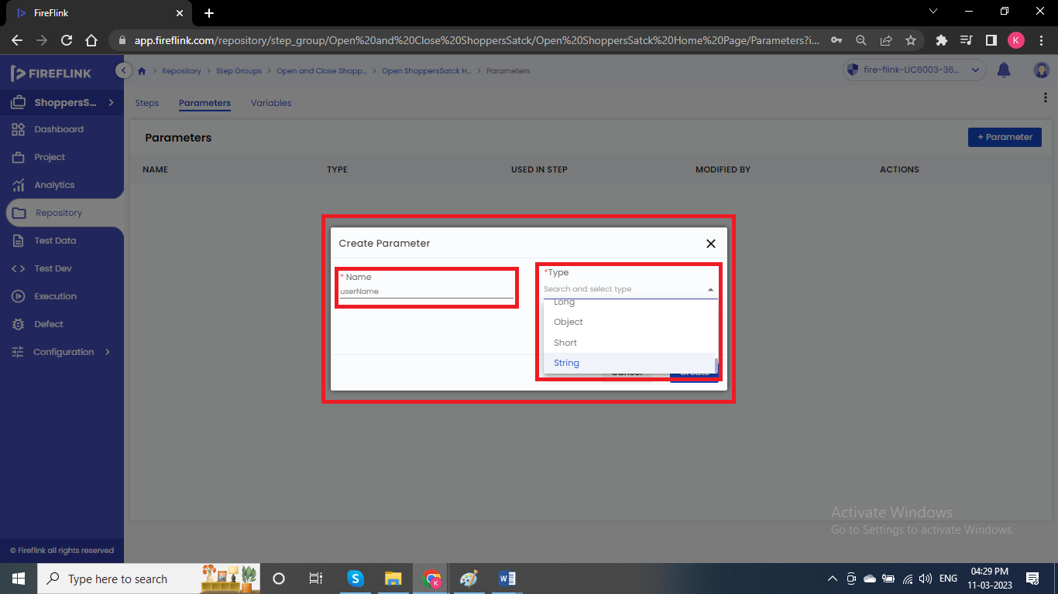

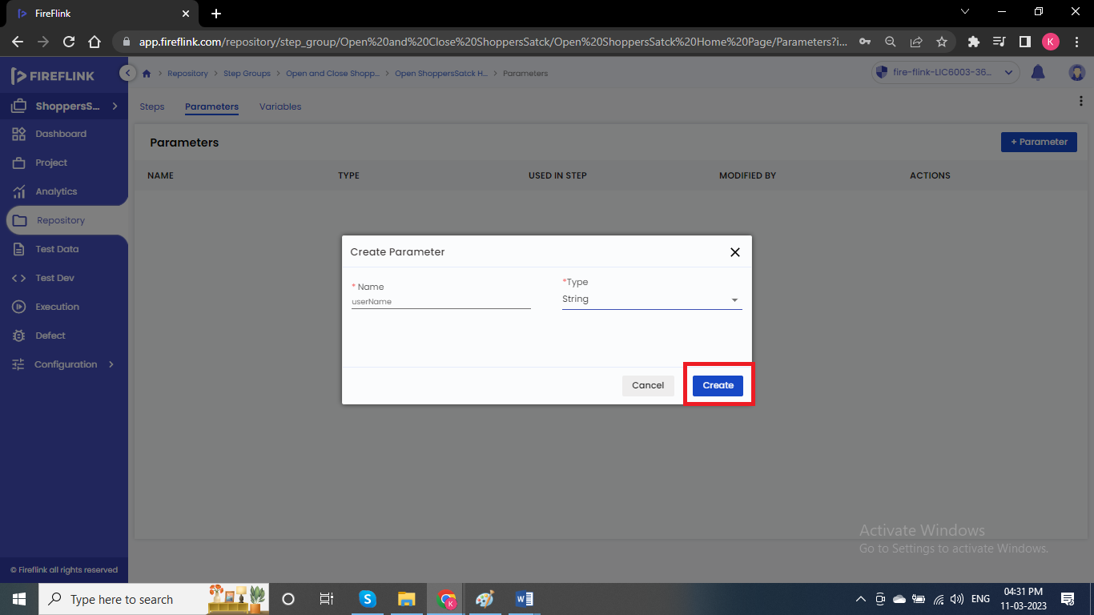

* Call the parameters while creating the Step Groups.
* The Step Groups which contains parameters we will call them as Parameterized Step Group.
* Step Group variables are local variables for that particular step.
* Select the Step Group parameters inside the step of a Step Group.

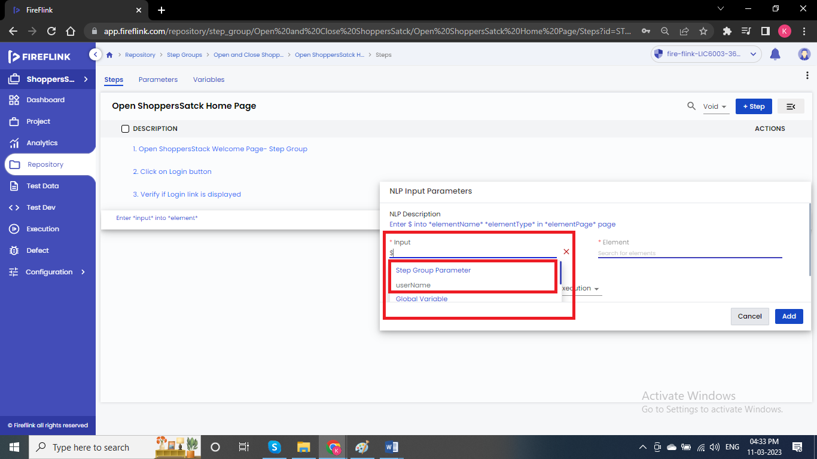

**Assign Step Return Value to:**

* Any verification NLP’s in FireFlink will return True (or) False.
* If actual value is matching with expected, then it will return True or else False.
* Now if this NLP’s returning the value we have to store of capture those values somewhere (Variables).

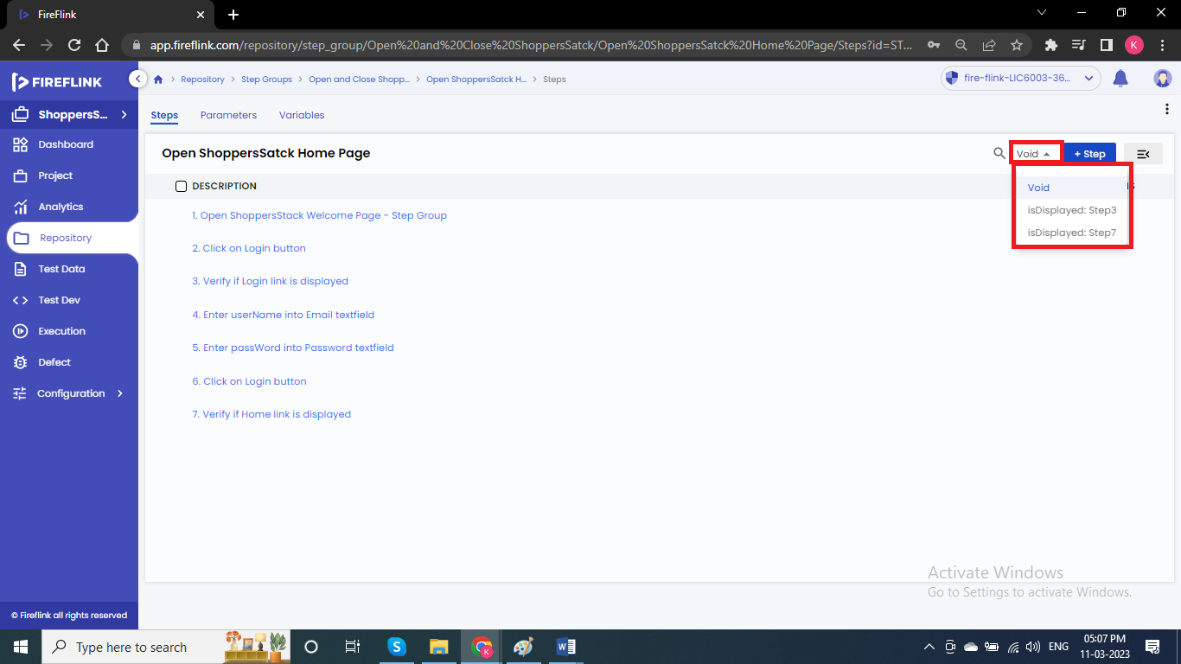

**Types of NLP’s:**

* There are 4 types of NLP’s based on the input and output.

1.NLP with no input and with no output.

2.NLP with no input and with output.

3.NLP with input and with output.

4.NLP with input and with no input.